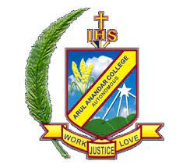
ARUL ANANDAR COLLEGE (AUTONOMOUS)
KARUMATHUR, MADURAI -625 514
DEPARTMENT OF PHYSICS

MoU
- The P.G and Research Department of Physics, Arul Anandar College, Karumathur, Madurai made a Memorandum of Understanding (MOU) with the School of Space Research, College of Applied Science, Kyung Hee University, Republic of South Korea to establish the activities such as exchange of faculties and research scholars, collaborative research and joint meetings, exchange of information, publications and materials for academic purposes which comes in to effective from 2020 – 2021 academic year.

- The P.G and Research Department of Physics, Arul Anandar College, Karumathur, Madurai made a Memorandum of Understanding (MOU) with the P.G & Research Department of Physics, Jayaraj Annapackkiam College for Women, Periyakulam, Theni district to encourage the exchange activities such as exchange of research scholars, joint conferences, joint research programmes, exchange of research information and materials etc. which comes in to effective from 12th September 2019.

