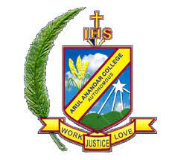
ARUL ANANDAR COLLEGE (AUTONOMOUS)
KARUMATHUR, MADURAI -625 514
DEPARTMENT OF COMMERCE WITH COMPUTER APPLICATIONS
Memorandum of understanding between
Arul Anandar College (Autonomous), Karumathur, Madurai- 625 514
And
RLFA – Reserve Line Football Academy, Madurai. - 625 014.
Rev. Fr. Godwin Rufus, SJ Principal, Arul Anandar College, Karumathur, Madurai - 625 514
And
A. Sundararaja, Secretary, RLFA – Reserve Line Football Academy, Madurai. - 625 014.

are interested in an academic tie -up in developing Football Skills with the following terms with effect from _____-
Article 1
To have professional players from RLFA – Reserve Line Football Academy, Madurai to conduct the Football workshop in the Department of Physical Education, Arul Anandar College.
Article 2
Permitting the students of the Department of Physical Education, Arul Anandar College to participate in the matches organized by the academy.
Article 3
Helping the final year students of the Department of Physical Education, Arul Anandar College, to undergo short term internship at RLFA, Madurai.
Article 4
Inviting RLFA- Reserve Line Football Academy to Arul Anandar College for on campus placement. The Memorandum of Understanding become effective from the date the agreement being singed and will be valid for six year and it will be renewed after six years.

