ARUL ANANDAR COLLEGE (AUTONOMOUS)
KARUMATHUR, MADURAI -625 514
DEPARTMENT OF INFORMATION TECHNOLOGY AND MANAGEMENT

Department of Information Technology and Management had signed MOU for the following years.
1. ACADEMIC YEAR: 2019-2020
MOU DOCUMENT
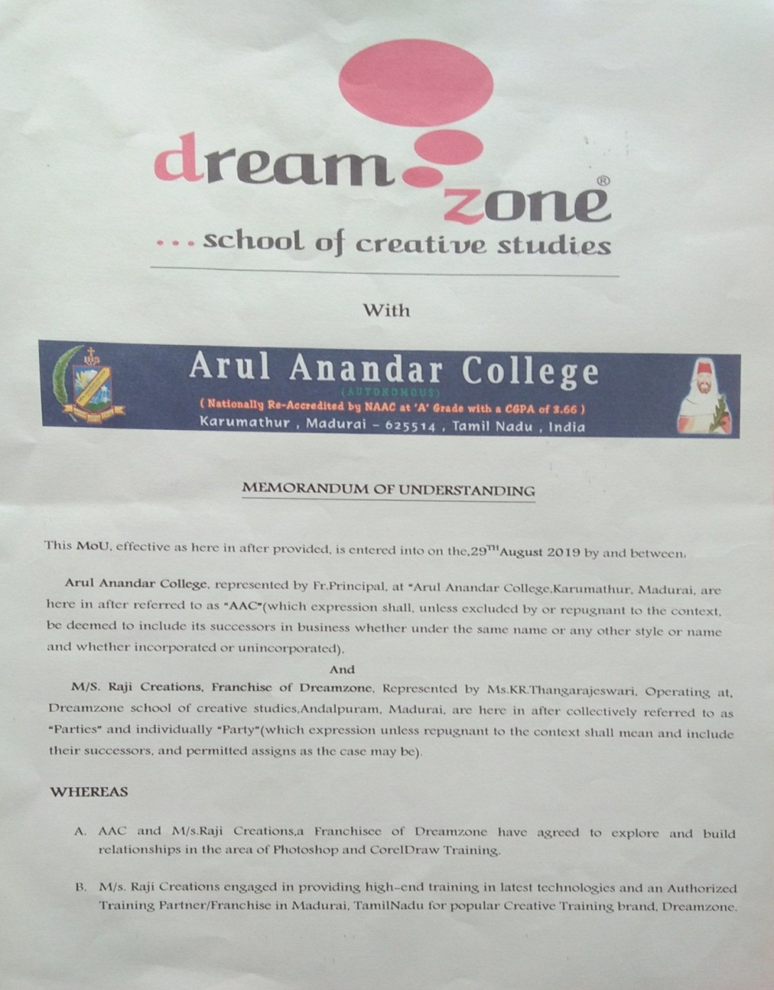
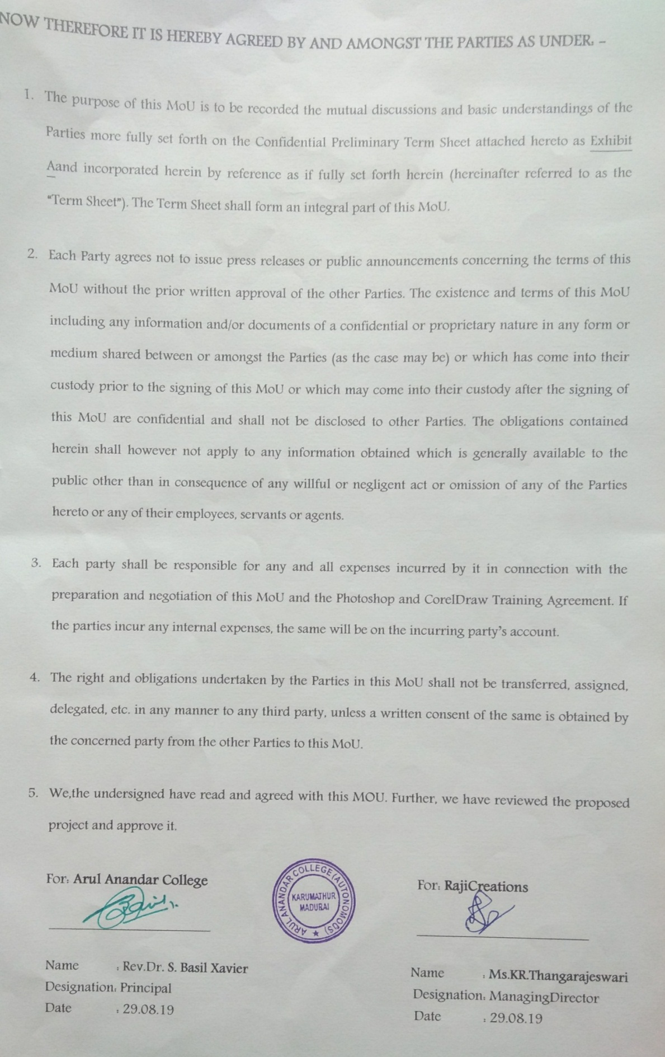
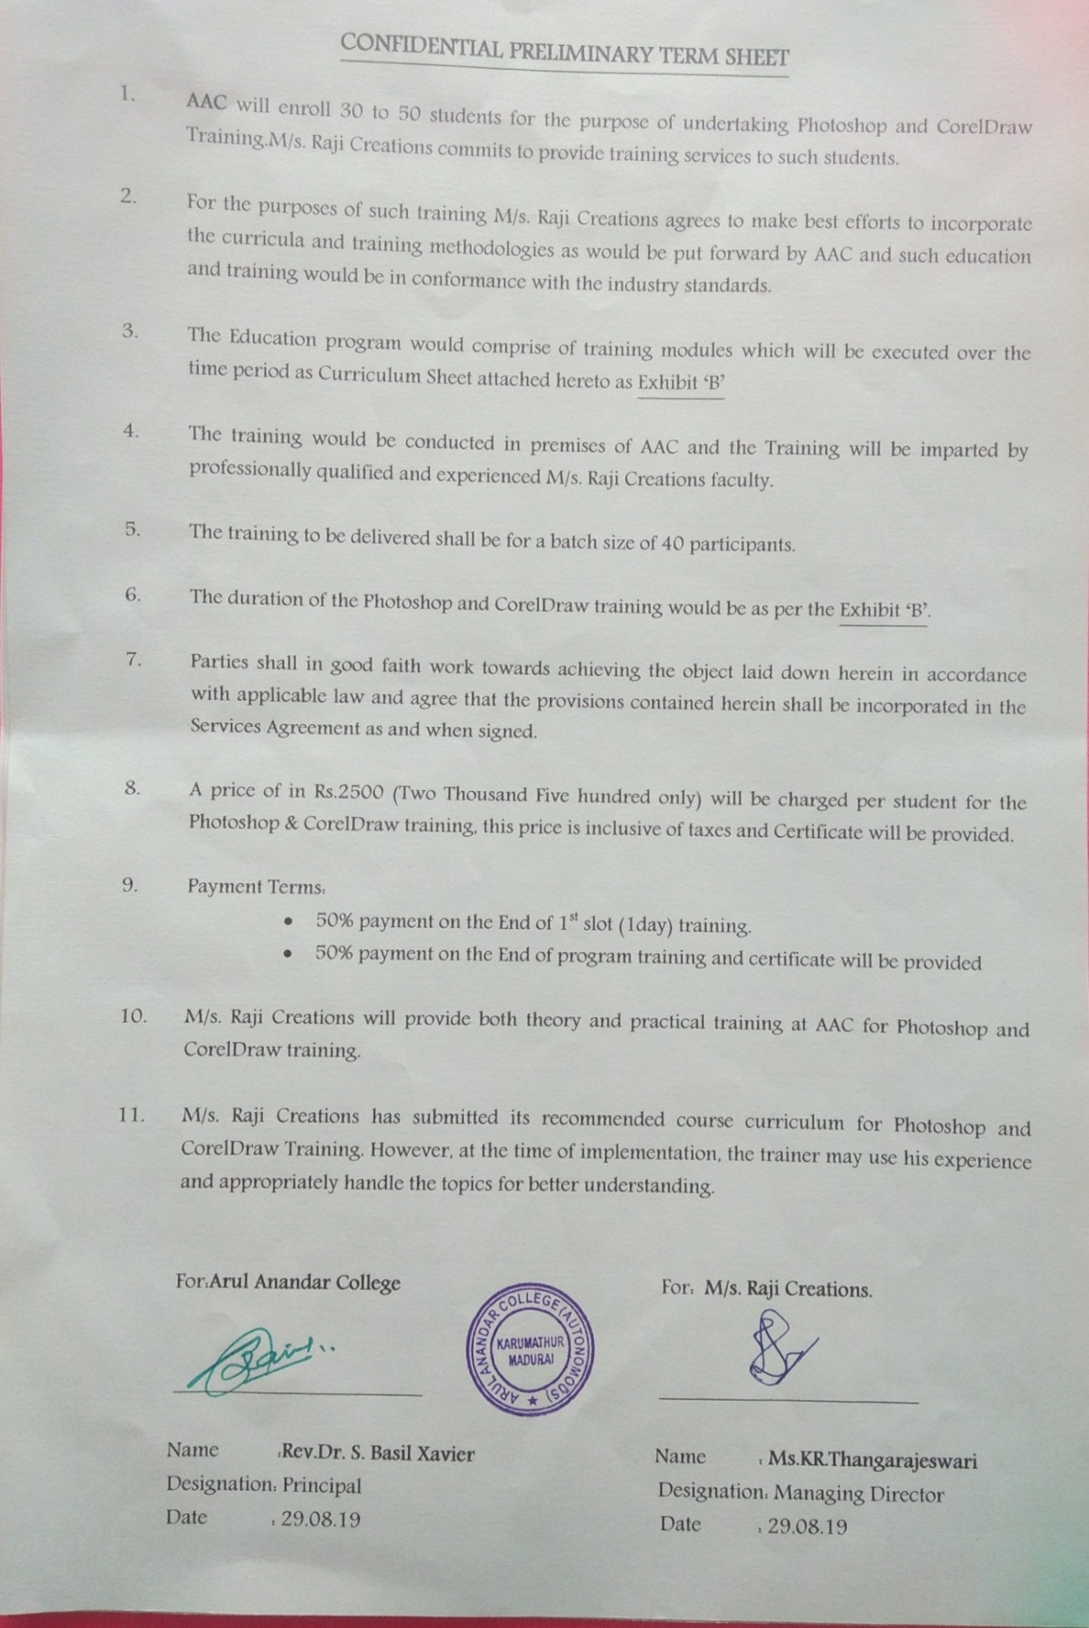
MOU with DREAMZONE Pvt ltd
28-08-2019
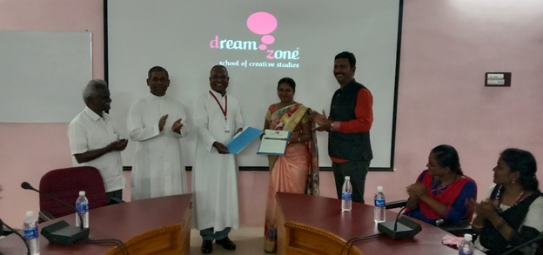
CERTIFICATE
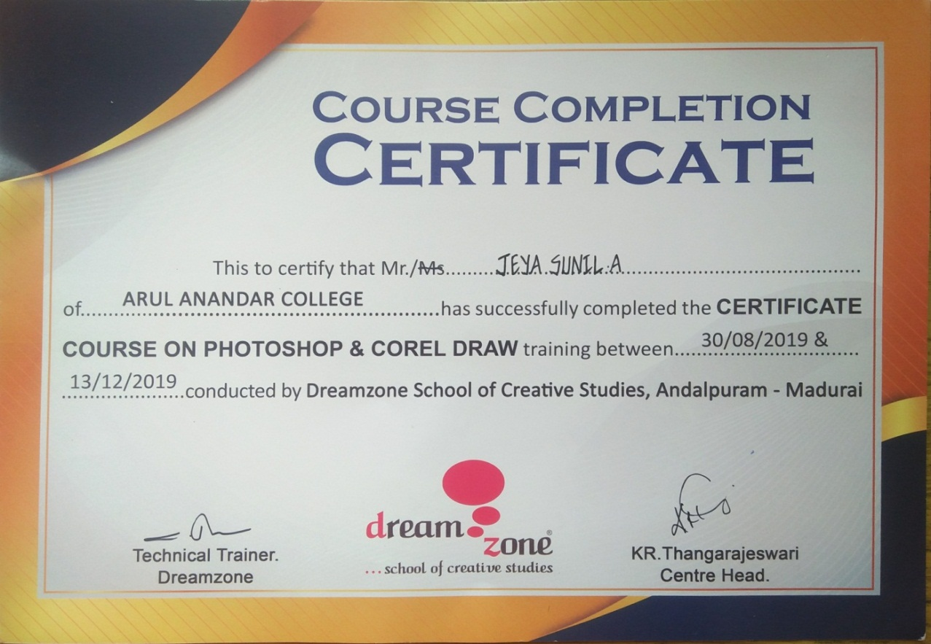

Invitation
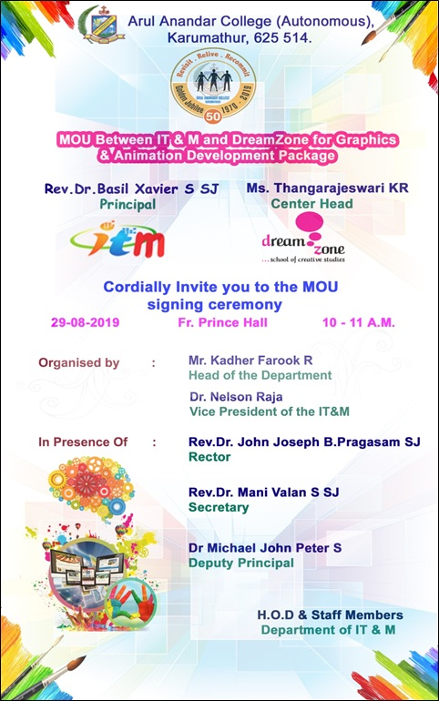

2. ACADEMIC YEAR: 2018-2019
DOCUMENT
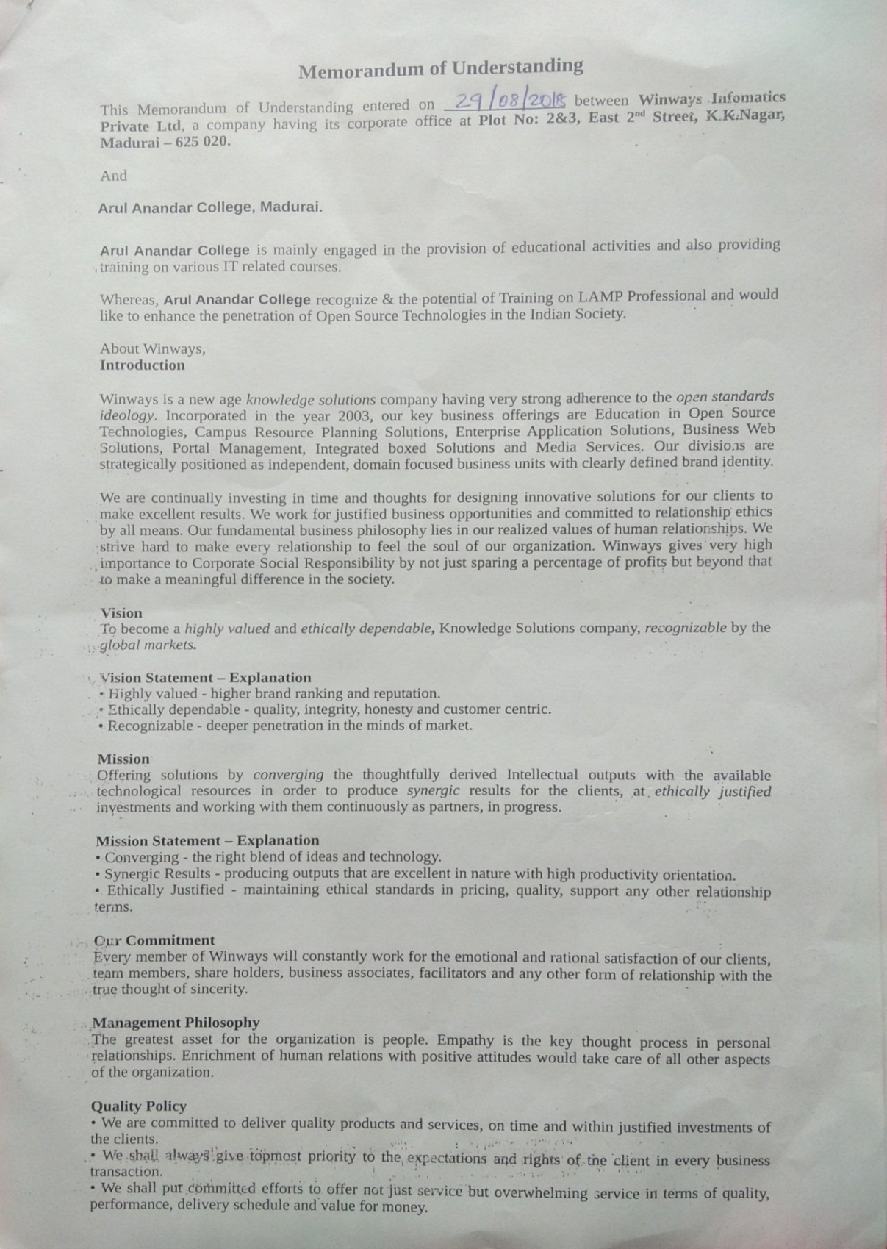
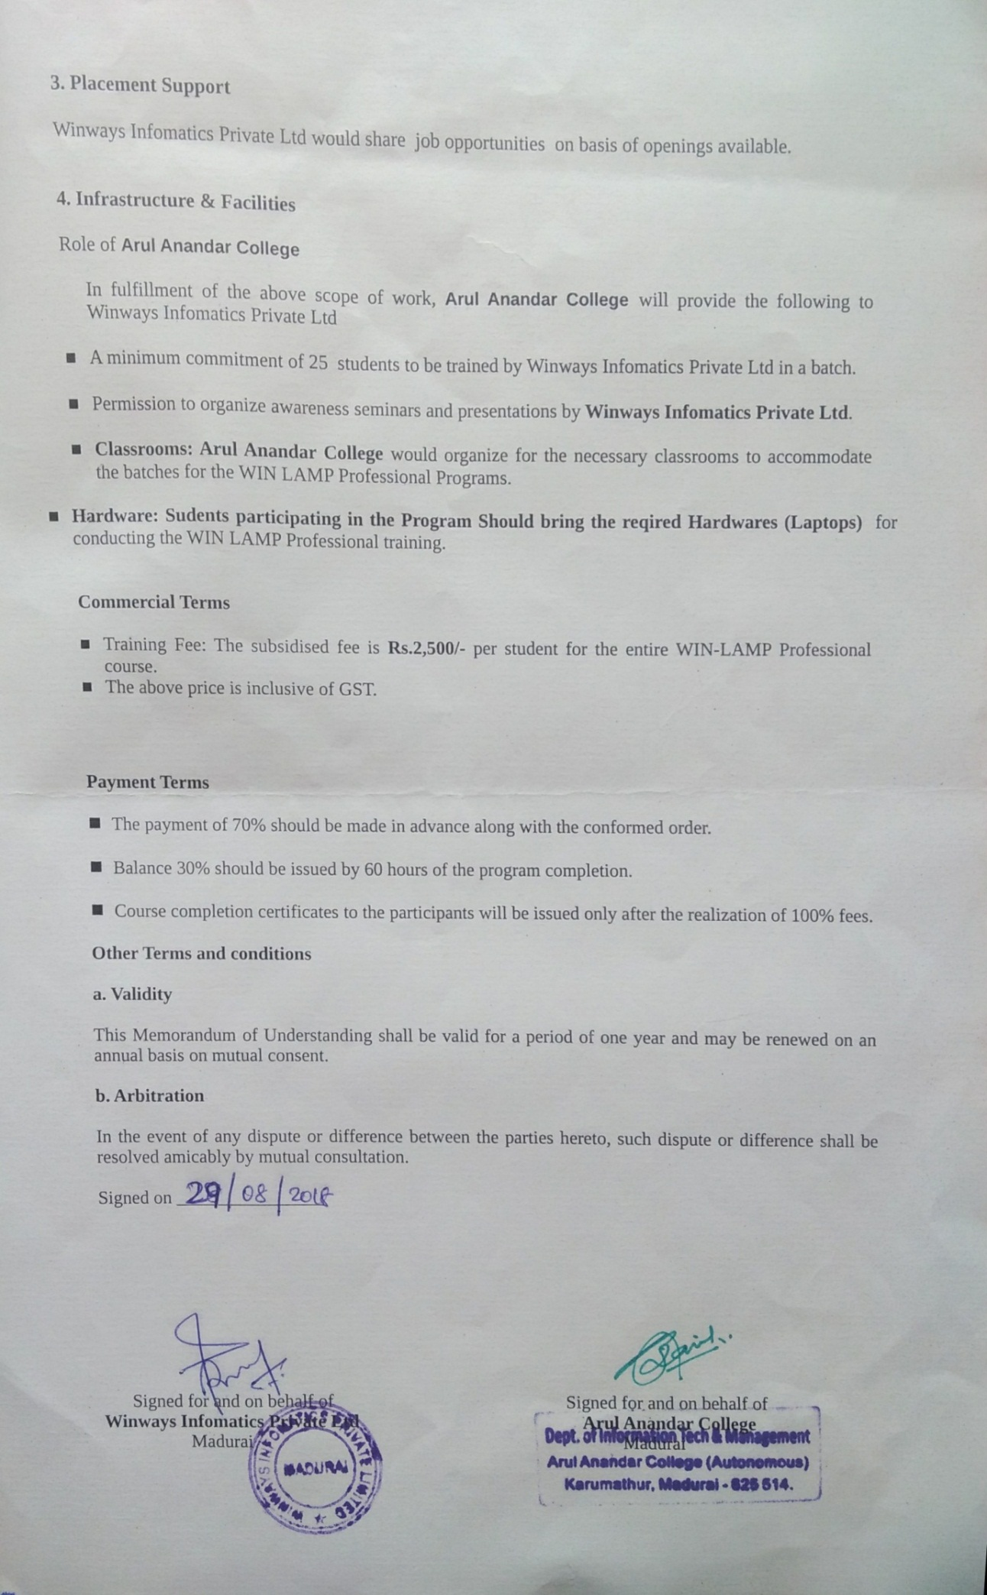
MOU with Winways Pvt ltd
29-08-2018
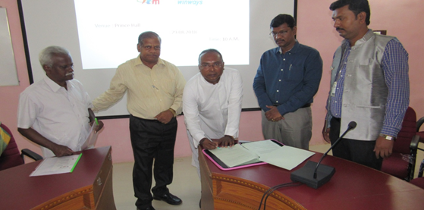
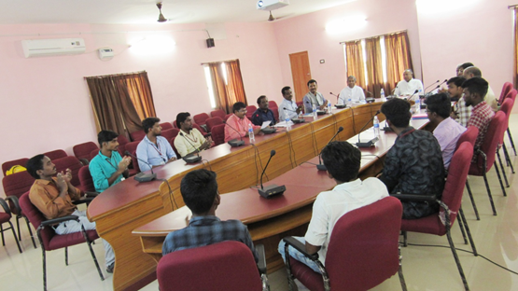
CERTIFICATE
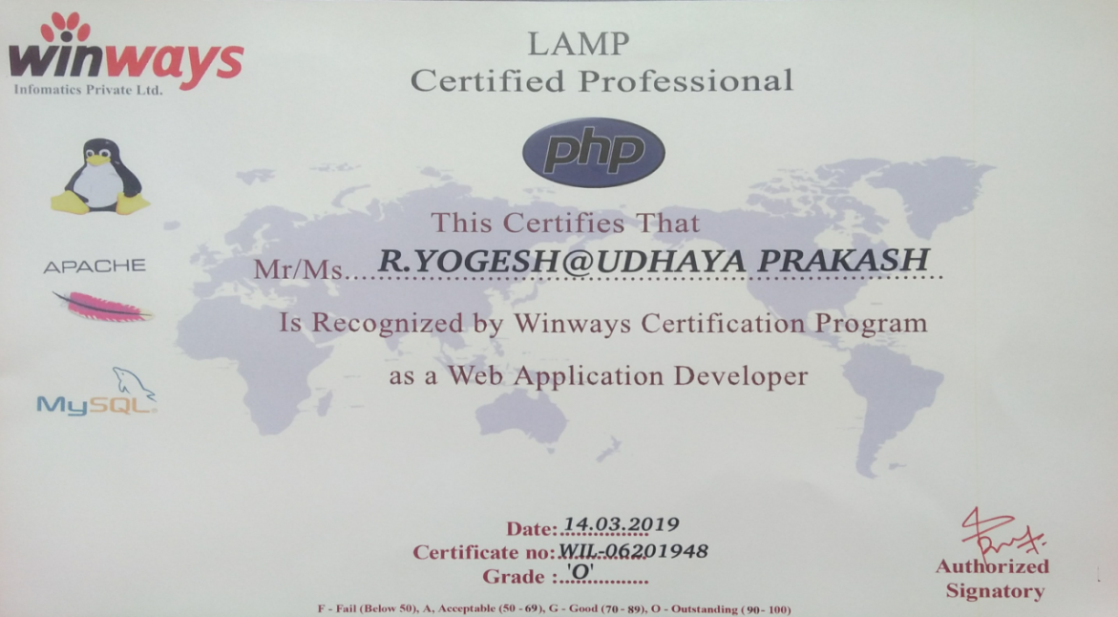
INVITATION
