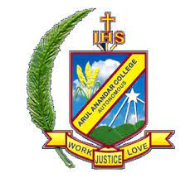**ARUL ANANDAR COLLEGE (AUTONOMOUS)**

**KARUMATHUR, MADURAI -625 514**

**DEPARTMENT OF COMPUTER SCIENCE AND APPLICATIONS**

MoU

We the department of computer science and Applications had signed a MoU with Mr.A. Sureshkumar , Director, SMIT Tech, Madurai for project training of III B.Sc Computer Science students.

