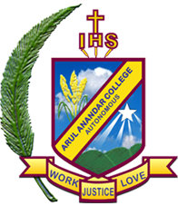
DEPARTMENT OF BUSINESS ADMINISTRATION
ARUL ANANDAR COLLEGE
KARUMATHUR- 625514

The Department of Business Administration, Arul Anandar College has signed the Memorandum of Understanding (MOU) with the following five companies.

S.NO | Name of the Company | Date/ Year
1. | Adhiyaman Agro Products (P) LTD, Agaram, Krishnagiri-635204 | 08/12/2020
2. | Coirflex Mattress India Private Limited, Marandhahilli, Dharmapuri | 08/12/2020
3. | LDS Tehc Private limited , Thandalam, Sriperumbudur | 11/12/2020
4 | Seforge Limited , Karumathampatti, Coimbatore | 14/12/2020
5. | Sri Kannattal Spinning Mills Private Limited ,Okkur, Sivagangai Distict. | 30/03/2021

1. Adhiyaman Agro Products (P) LTD, Agaram, Krishnagiri
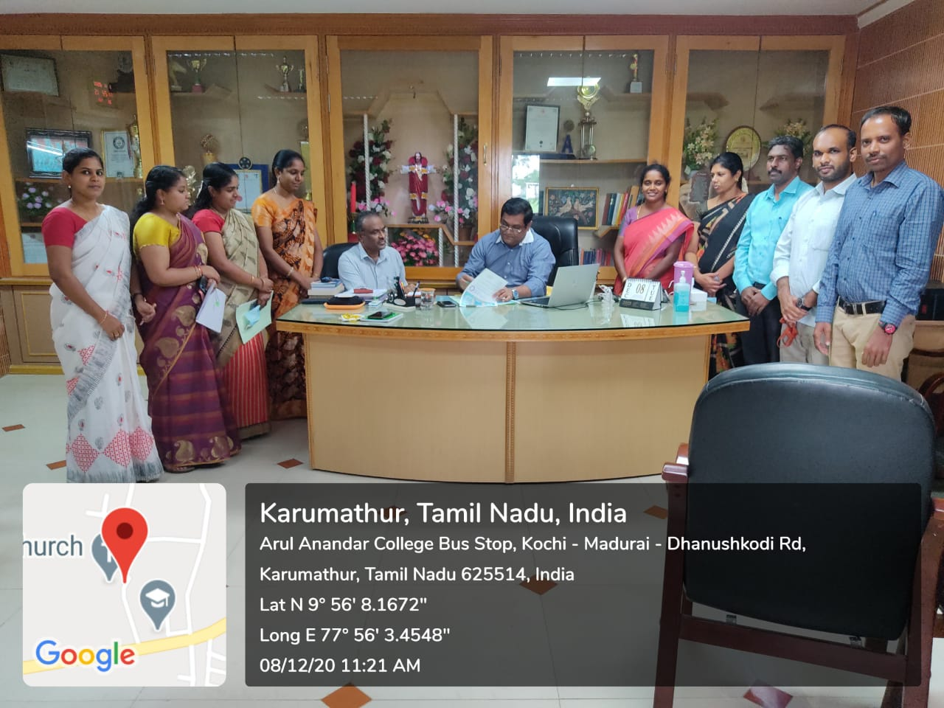

2. Coirflex Mattress India Private Limited, Marandhahilli, Dharmapuri
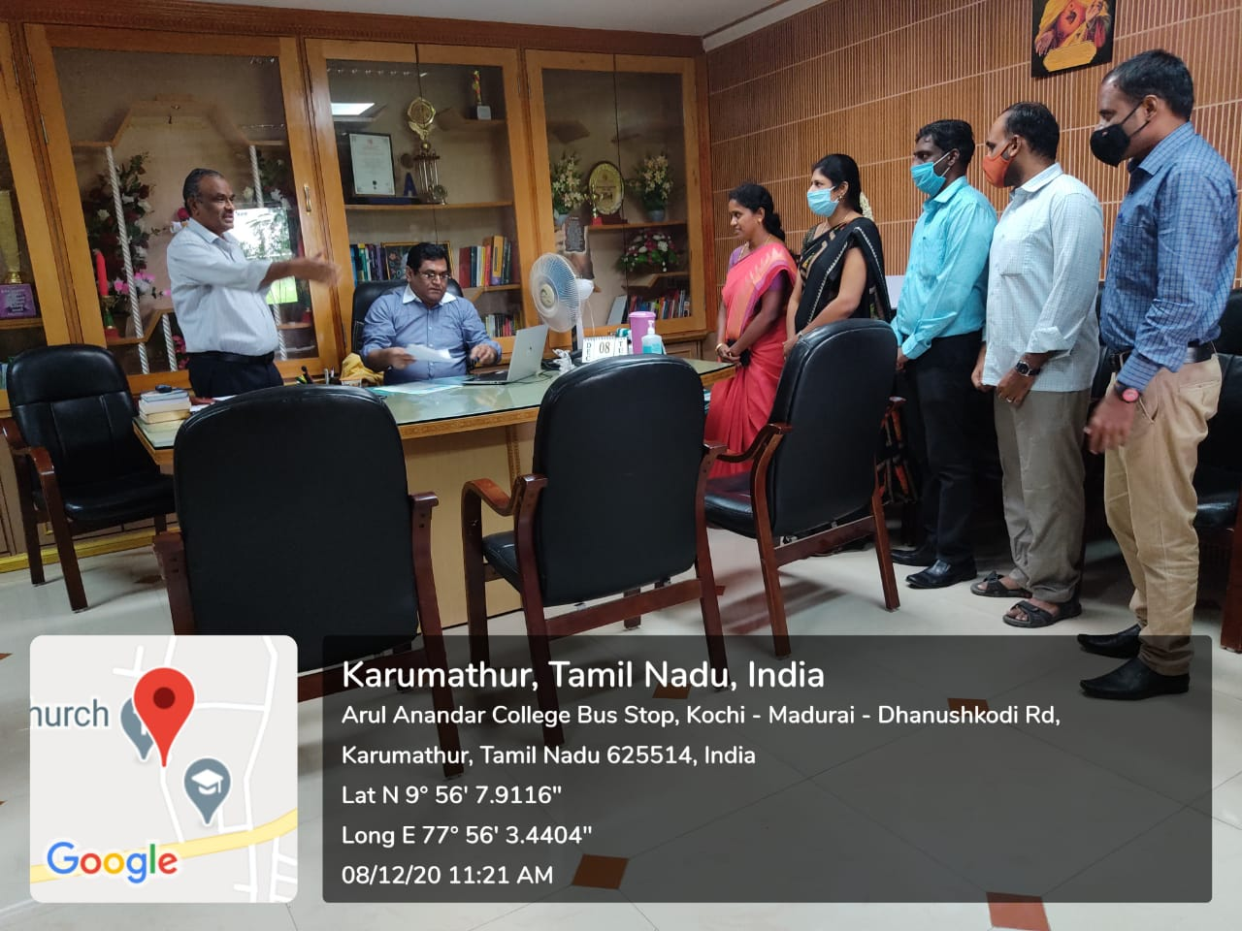

3. LDS Tech Private Limited, Thandalam, Sriperumbudur 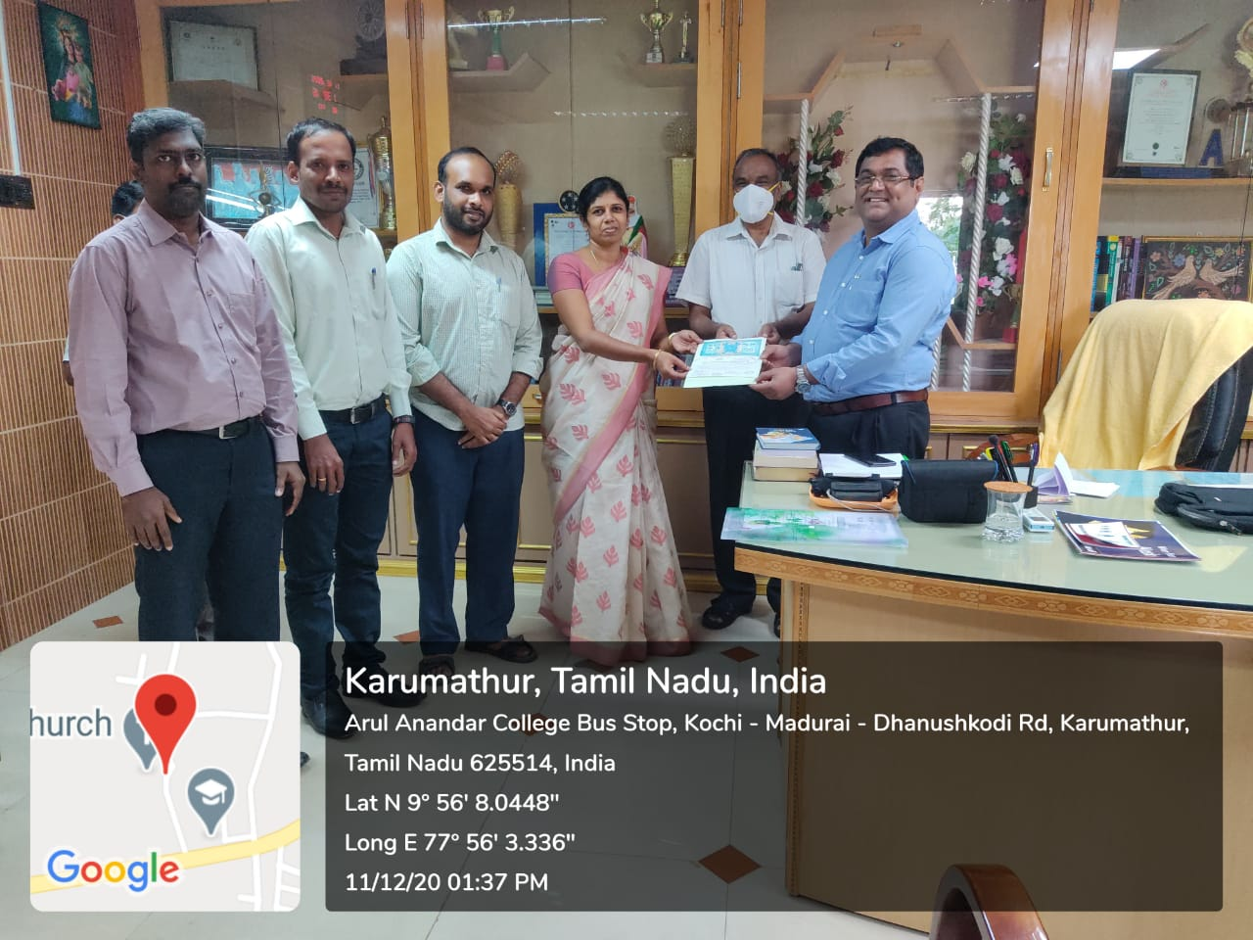

4. Seforge Limited, Karumathampatti, Coimbatore
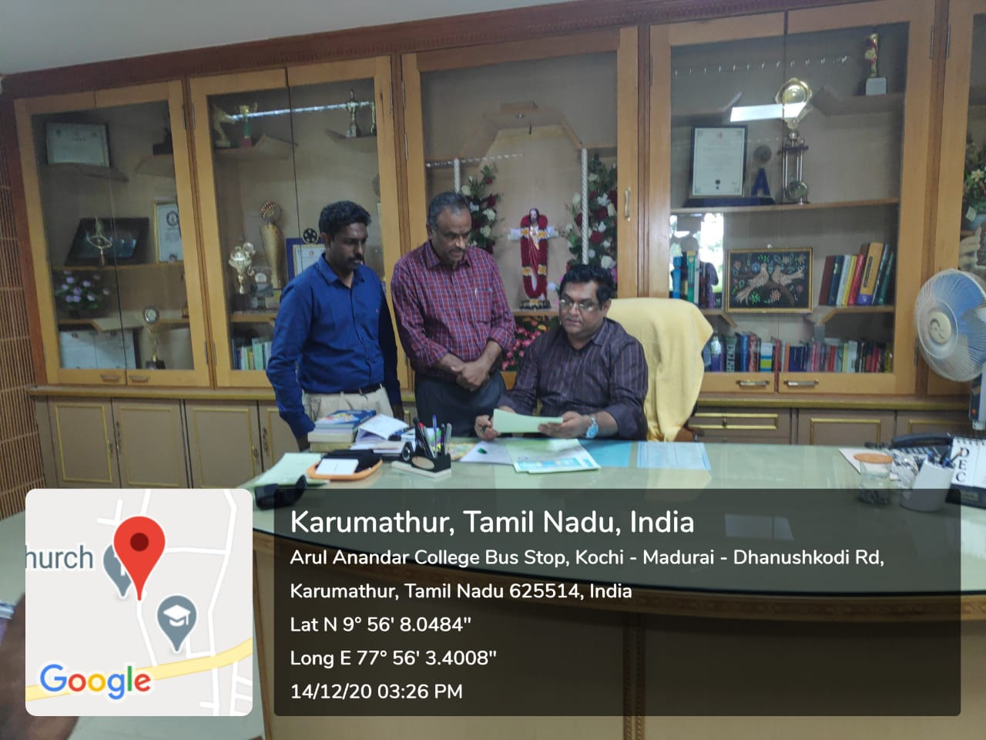

5. Sri Kannattal Spinning Mills Private Limited ,Okkur, Sivagangai Distict.


